- Given a small dataset of 2D points representing food delivery locations (e.g., [2,3], [5,8], [1,2], [6,9], [7,7]), plot the points on graph paper or using matplotlib, randomly pick two initial centroids, and manually assign each point to the nearest centroid using Euclidean distance.
Part 1: Manual K-Means Assignment (Euclidean Distance)
Given the delivery points:
- $P_{1}=\left[2,3\right]$
- $P_{2}=\left[5,8\right]$
- $P_{3}=\left[1,2\right]$
- $P_{4}=\left[6,9\right]$
- $P_{5}=\left[7,7\right]$
Let's pick two initial centroids randomly:
- Centroid 1 ($C_{1}$): $\left[2,3\right]$
- Centroid 2 ($C_{2}$): $\left[7,7\right]$
The Euclidean distance formula between two points $\left(x_{1},y_{1}\right)$ and $\left(x_{2},y_{2}\right)$ is:
$$d=\sqrt{{\left(x_{2}-x_{1}\right)}^{2}+{\left(y_{2}-y_{1}\right)}^{2}}$$
Step-by-Step Distance Calculations & Assignments:
- Point $\left[2,3\right]$:
  - Distance to $C_{1}\left(\left[2,3\right]\right)=\sqrt{{\left(2-2\right)}^{2}+{\left(3-3\right)}^{2}}=0$
  - Distance to $C_{2}\left(\left[7,7\right]\right)=\sqrt{{\left(7-2\right)}^{2}+{\left(7-3\right)}^{2}}=\sqrt{25+16}=\sqrt{41}≈6.40$
  - Assignment: Cluster 1 ($C_{1}$)
- Point $\left[5,8\right]$:
  - Distance to $C_{1}\left(\left[2,3\right]\right)=\sqrt{{\left(5-2\right)}^{2}+{\left(8-3\right)}^{2}}=\sqrt{9+25}=\sqrt{34}≈5.83$
  - Distance to $C_{2}\left(\left[7,7\right]\right)=\sqrt{{\left(7-5\right)}^{2}+{\left(7-8\right)}^{2}}=\sqrt{4+1}=\sqrt{5}≈2.24$
  - Assignment: Cluster 2 ($C_{2}$)
- Point $\left[1,2\right]$:
  - Distance to $C_{1}\left(\left[2,3\right]\right)=\sqrt{{\left(1-2\right)}^{2}+{\left(2-3\right)}^{2}}=\sqrt{1+1}=\sqrt{2}≈1.41$
  - Distance to $C_{2}\left(\left[7,7\right]\right)=\sqrt{{\left(7-1\right)}^{2}+{\left(7-2\right)}^{2}}=\sqrt{36+25}=\sqrt{61}≈7.81$
  - Assignment: Cluster 1 ($C_{1}$)
- Point $\left[6,9\right]$:
  - Distance to $C_{1}\left(\left[2,3\right]\right)=\sqrt{{\left(6-2\right)}^{2}+{\left(9-3\right)}^{2}}=\sqrt{16+36}=\sqrt{52}≈7.21$
  - Distance to $C_{2}\left(\left[7,7\right]\right)=\sqrt{{\left(7-6\right)}^{2}+{\left(7-9\right)}^{2}}=\sqrt{1+4}=\sqrt{5}≈2.24$
  - Assignment: Cluster 2 ($C_{2}$)
- Point $\left[7,7\right]$:
  - Distance to $C_{1}\left(\left[2,3\right]\right)=\sqrt{{\left(7-2\right)}^{2}+{\left(7-3\right)}^{2}}=\sqrt{41}≈6.40$
  - Distance to $C_{2}\left(\left[7,7\right]\right)=0$
  - Assignment: Cluster 2 ($C_{2}$)
Final Clusters:
- Cluster 1: $\left[2,3\right],\left[1,2\right]$
- Cluster 2: $\left[5,8\right],\left[6,9\right],\left[7,7\right]$

===========================================================================

- Write a Python function assign_clusters(points, centroids) that takes a list of points and a list of centroids, and returns a list showing which cluster each point belongs to using Euclidean distance.
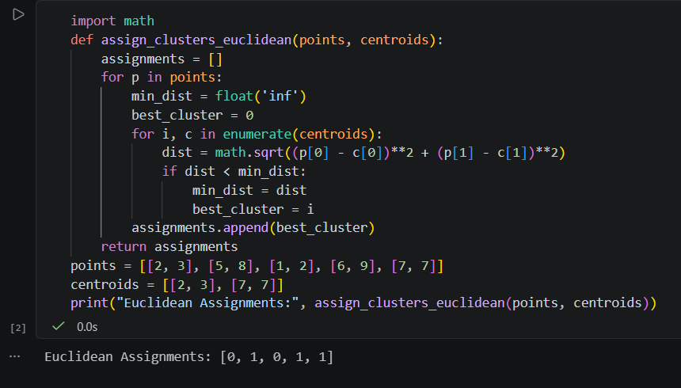

===========================================================================

- Update your assign_clusters code to work with Manhattan distance as well. Allow the user to choose between 'euclidean' and 'manhattan' as a parameter.
$$d=|x_{2}-x_{1}|+|y_{2}-y_{1}|$$

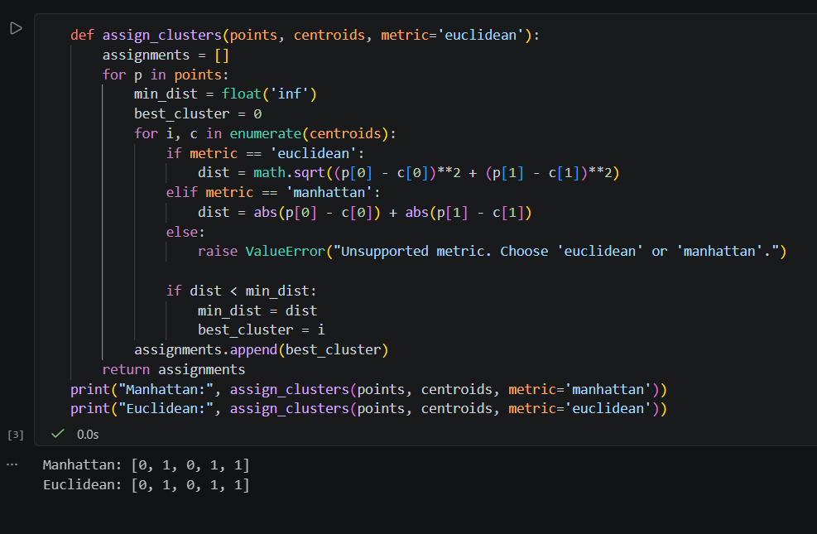

===========================================================================

- Implement a function update_centroids(points, assignments, k) that calculates the new centroid for each cluster as the mean of the assigned points. Test it with a sample dataset of your choice.
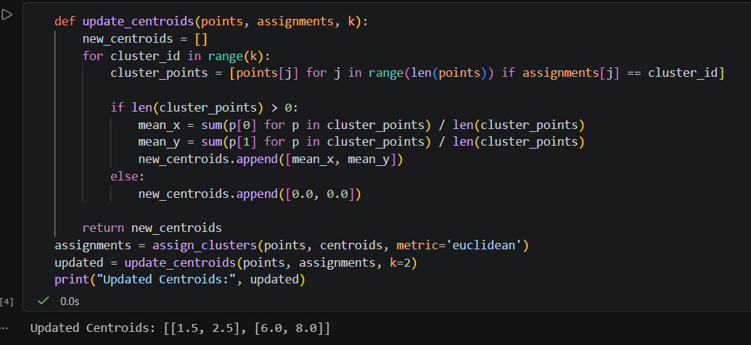

- Use the Elbow Method to determine the optimal number of clusters (k) for a dataset of your choice (e.g., favorite songs by tempo and danceability, or Zomato restaurant ratings and price). Plot the within-cluster sum of squares for k=1 to k=6 and identify the 'elbow' point. Use sklearn's KMeans and matplotlib for plotting.
